LDA is like PCA, but focus on maximizing the separability among known categories

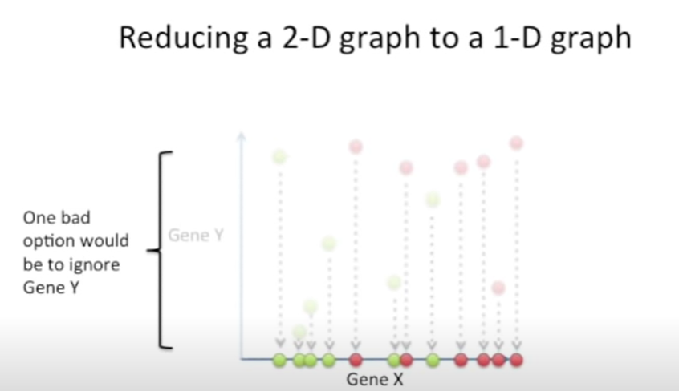

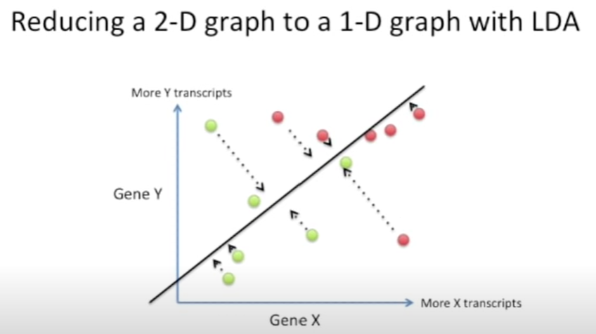

LDA creates new axis and project data on that new axis => HOW?

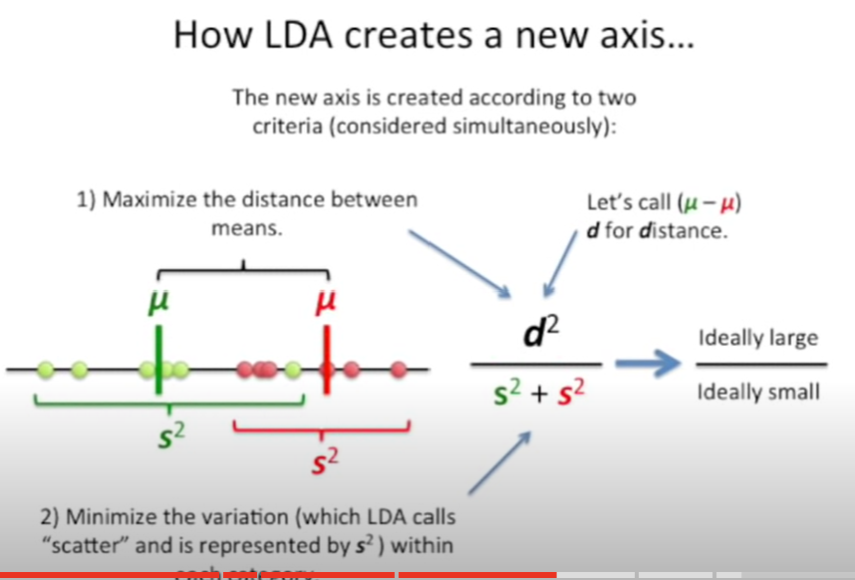

1. Maximize the distance
2. Minimize the variation (scatter)

WHY distance and scatter are important

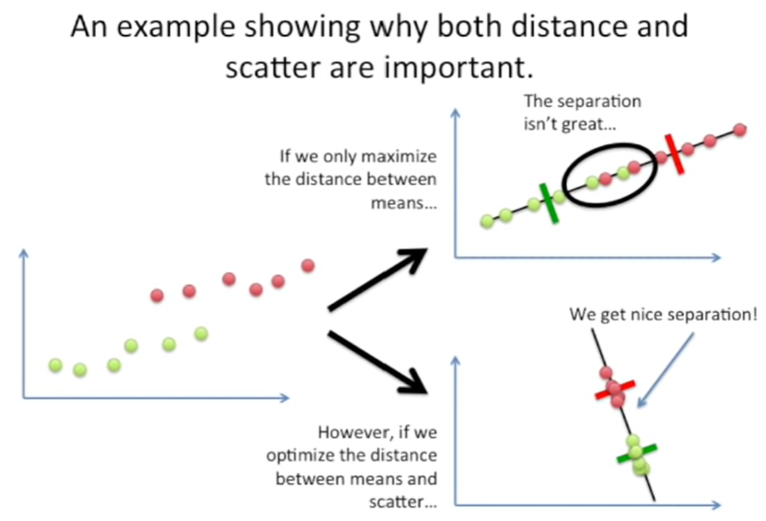

With cases that have more than 2 dimensions => similar

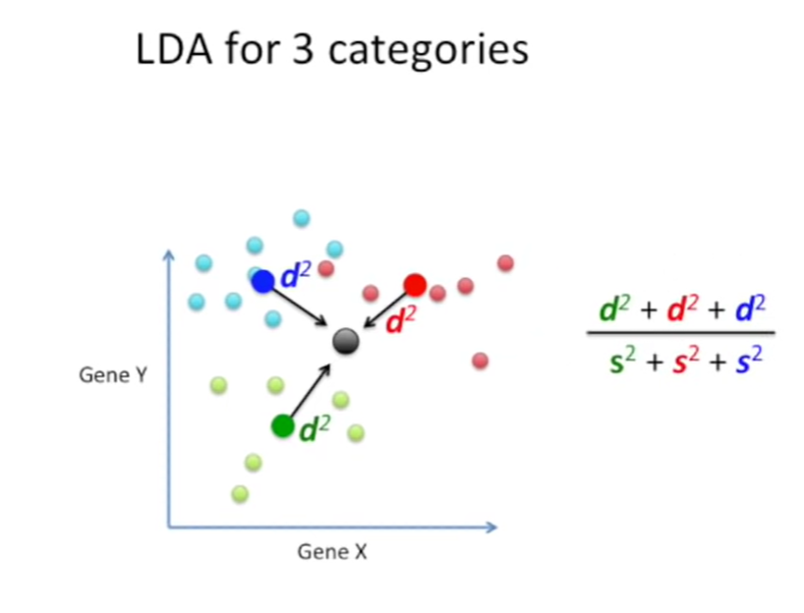

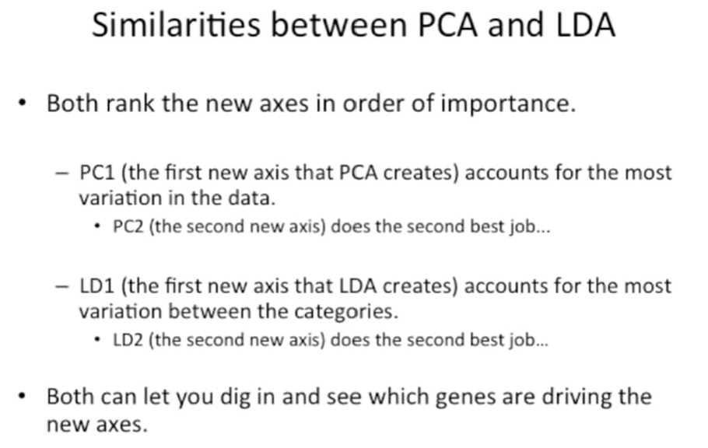

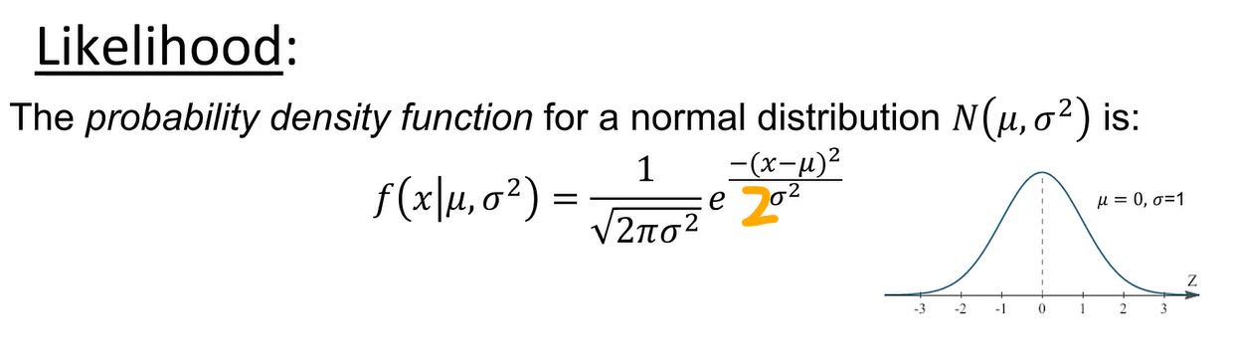

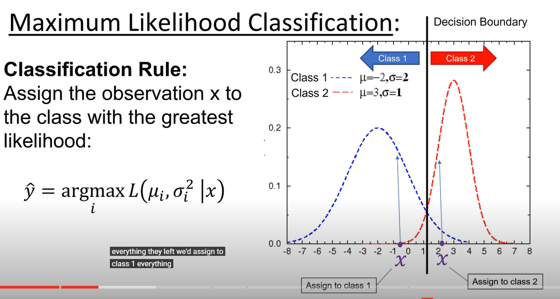

SKIP QDA